

Inverness Area Command
Newsletter – June 2023

This newsletter features updates on the work carried out across the Inverness area command area of the following teams and officers:

- Community Beats Team
- City Centre Team
- Divisional Alcohol & Violence Reduction Team

These teams work alongside the response ‘999’ shifts in addition to other Police teams and units based in the Highlands, examples – child protection, roads policing and firearms licensing.

Community Beats

Community Beats Team
Your current community beat team is, from left to right –
Sergeant Brian Bisset, PC Jo Barclay, PC Laura Kerr, PC Cailean MacLeod, Inspector Stuart Fitzpatrick, PC Keith Whitelaw, PC Katie Johnstone and PC Stuart Connell.
Community Beat officers cover the whole of the city of Inverness area and the rural beats of Ardersier, Daviot, Tomatin and Strathdearn.
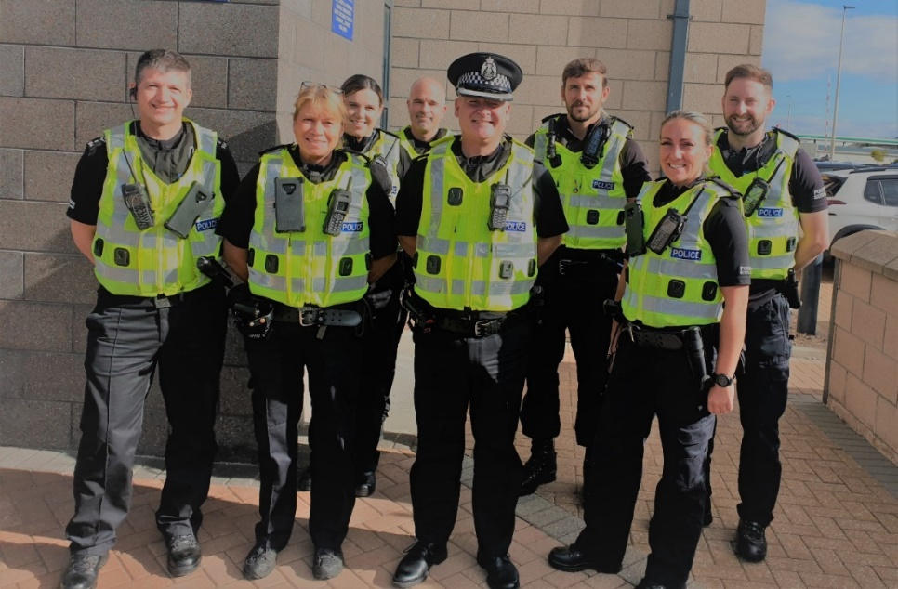

Road safety
The community beats team has continued to work closely with various schools across the city during ‘drop off’ and ‘pick up times’.
Following reports of speeding the following areas have had a Police presence with the Pro-laser ‘speed-gun’: Old Edinburgh Road, Leachkin Road, Balnakyle Road, various streets in the Dalneigh area, Sunnyside area and other areas within the city.
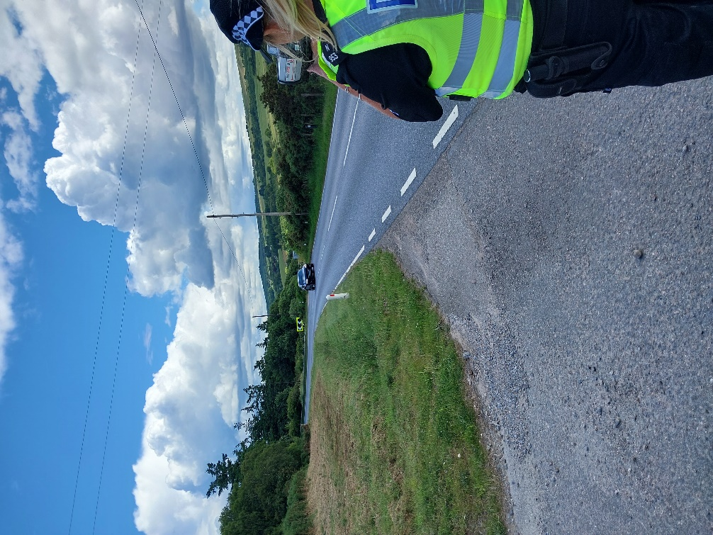

The community beats team continues to receive various complaints about parking issues in Drakies, Raigmore and Hilton. Whilst enforcement of parking specific offences is a matter for the Highland Council and their traffic wardens to enforce as they were decriminalised several years ago, Police will tackle instances of dangerous parking which is a specific offence under the Road Traffic Act 1988. Examples of dangerous parking – parking on zig zags outside schools at end of school day or parked right across a road junction. Your community beat team will deal with any incidents of offences that fall under the Road Traffic Act 1988.

A lot of the parking issues reported to the community beat officers are inconsiderate and annoying parking rather than specific offences. Whilst there was a law made by the Scottish Government regarding parking on pavements it is yet to come into force legally. The community beat team has received various reports of abandoned motor vehicles, Police Scotland has no jurisdiction to remove abandoned motor vehicles, this is a matter which Highland Council who have the powers to remove and dispose of abandoned motor vehicles.

Anti-social behaviour
There has been reports of ongoing anti-social behaviour in the Crown area, Macdonald Park, Tomnahurich Cemetery and the canal. Beat officers have been increasing patrols in these areas and were actively working with local schools until the very end of term to try and tackle these issues.
Through-out the summer holidays, community beat officers will continue to patrol known areas of anti-social behaviour and engage with the local youths. As the nights are brighter and the children are not in school, there will naturally be in increase in the youths gathered in parks and public areas. On the whole, the youths we come across on patrols are just out enjoying the weather, catching up with friends and are polite and chatty when we stop to speak to them. However if you do see any anti-social behaviour then we would encourage you to contact 101 at the time, when it is ongoing so officers can be dispatched to the area to deal with it. Should you be unable to do this, you can complete the “CONTACT US” section on the Police Scotland website and the information will be passed through to us and we can include this in our patrol plans.

Drugs
Following reports of drug dealing activity in the around Glendoe Terrace, Wyvis Place, Esk Road, Oldtown Road and Kintail Crescent community beat officers we have provided extra patrols in that area in addition to the Divisional Alcohol and Violence Reduction Unit carrying out uniform and plain clothes patrols.
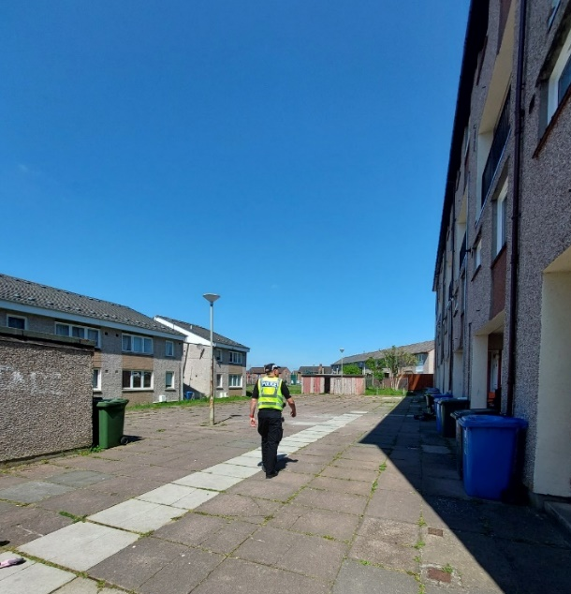
The following areas continue to highlight higher levels of drug activity; Merkinch, Hilton and Raigmore Estate. We continue to target patrols to areas highlighted by the community and rely on information provided as the ‘dealers’ will often move from one area to another following continued Police presence, for example lanes and other areas not immediately visible from the road.
Community beat officers continue to carry out searches of individuals to disrupt and deter drug dealing in your communities and continue to gather intelligence where we can. We do rely on people in the community passing information onto us.
Information regarding those involved in the misuse and supply of illegal drugs is crucial to enable Police enforcement activity. Information can be passed anonymously via Crime stoppers on 0800555111 or in strict confidence to your local community beat officer.

Community Engagement
Throughout this term, children from Merkinch Primary School have attended The Ledge climbing gym on Telford Street to learn new skills and enjoy a world class facility located here in the Highlands. After seeing the initial success, PC Connell was keen to have this continued through the summer holidays – with the generous help of the Co-Op who provided funding, 8 children will get the opportunity to carry on climbing during their holidays.
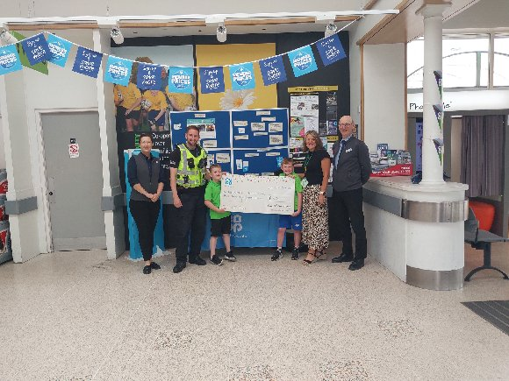
Community officers have continued to be on foot/bike/mobile patrol in local communities engaging with local people and offering help and reassurance to people where required.
The community beat team continue to engage with the local primary and secondary schools and frequently carry out foot patrols through the schools at break and lunch time, engaging positively with the children.
PC Johnstone attended at Central Primary school to talk to the children about online safety and social media.
PC Barclay attended at Duncan Forbes Primary to chat to the Primary 7’s about the dangers of drug use and the law.
In recent weeks PC Barclay and Kerr have attended at Raigmore Estates community coffee morning where they engaged with local residents and listened to any concerns they may have about issues in the local area.
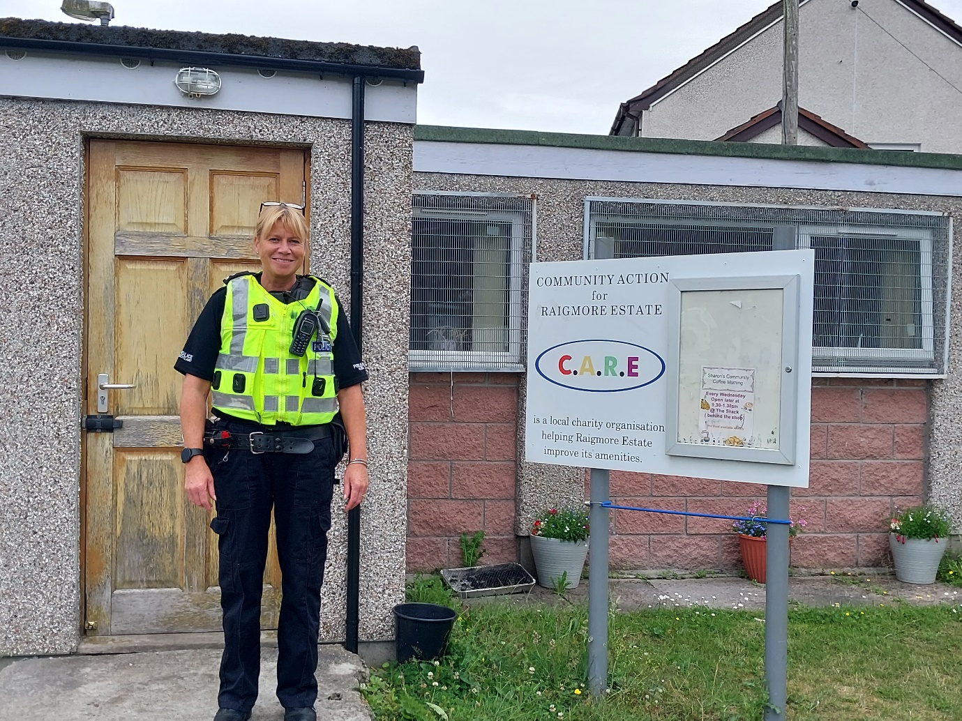

PC Whitelaw also had a visit from a local Cub Scout group who attended at the police station. They were given a tour and a demonstration of how our equipment worked. The children also tried on some police uniform and had the opportunity to go in the police car and to ask lots of questions.
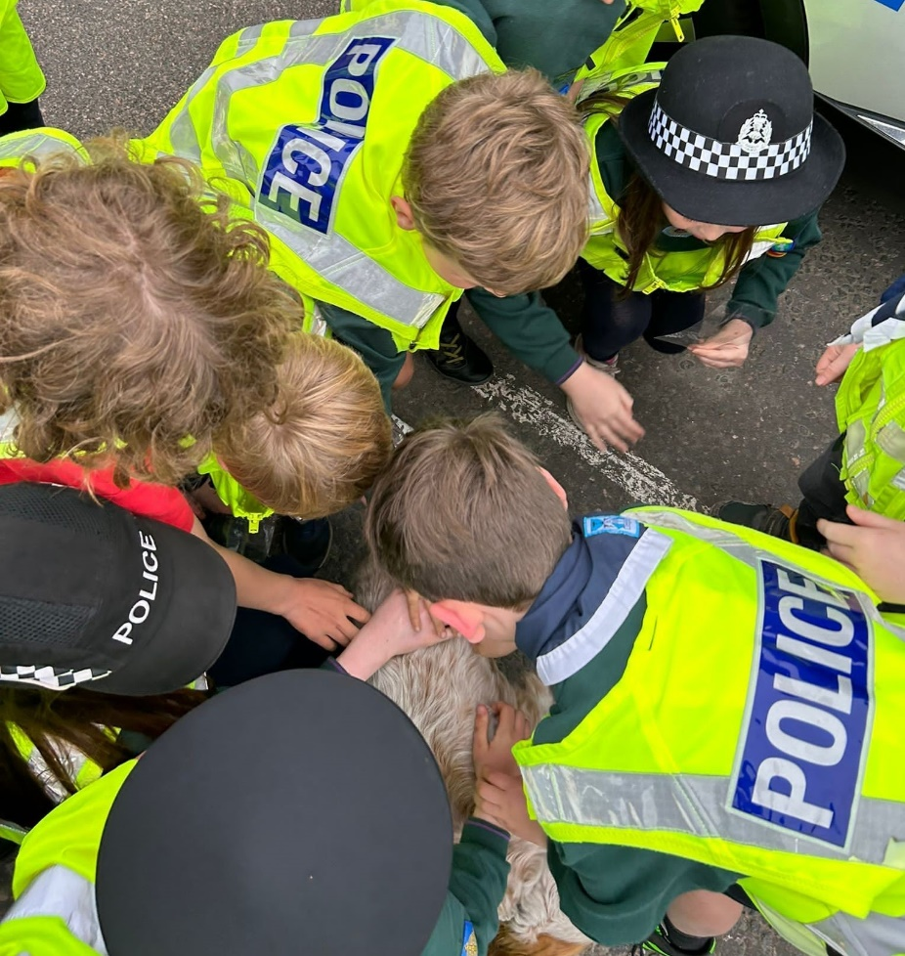
The children were delighted to be able to meet some of the police dogs on their visit.
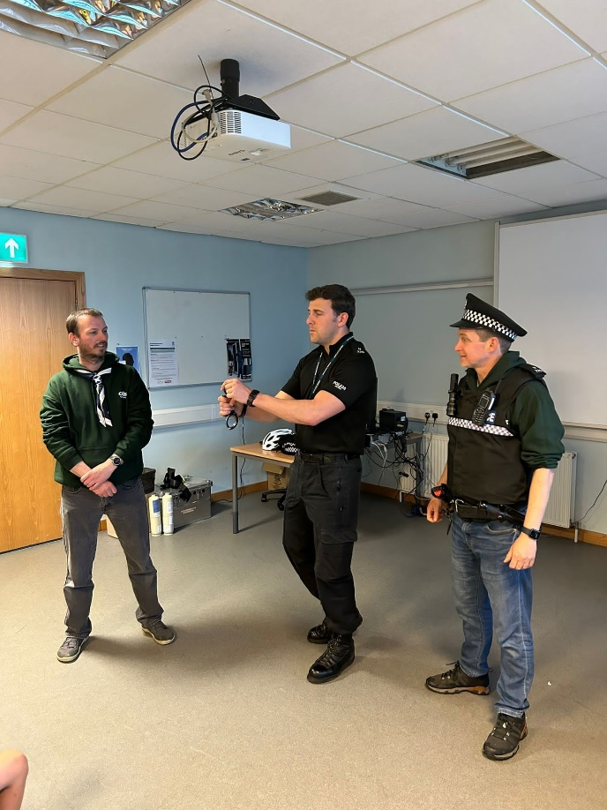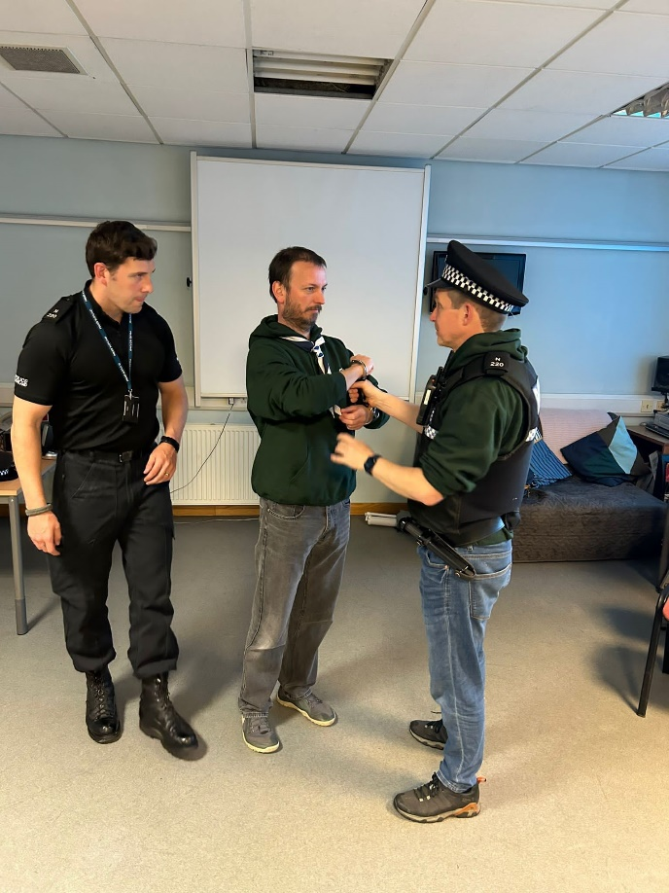

The community beats team will be arranging over the coming weeks and months, local community street surgeries across the city. This events are for any member of public to attend in person without an appointment to speak with their local community beat officer to discuss issues relating to crimes, anti-social behaviour, drug dealing and other Police related matters. These events will be advertised via the Highlands and Islands Police social media pages.

Other Duties
The team continues to support response shifts, major enquiries, court officer duties and specialism duties – child protection enquiries and mountain rescue team. These abstractions are essential in order to provide an overall Police service to all the communities across the Highlands and Islands.

CITY CENTRE

CITY CENTRE POLICING TEAM – JUNE 2023
This is a monthly general overview of the work being carried out by the City Centre Policing Team lead by Inspector Stuart Fitzpatrick and under the direction of A/PS Louise Hay. Our officers are currently PC Alan Heap, PC Adam Wilsher, PC Mathew Cameron, PC Lucille Ritchie, PC Ryan McGill, PC Arron Mackenzie and PC Arizona Morence. We are a small team who have the responsibility of policing the city centre of Inverness and all the challenges that this brings. We are regularly supported by our Special Constable colleagues.

New City Centre Sergeant
We would like to introduce our new City Centre Sergeant, Louise Hay, who has extensive experience in policing and who has transferred from Burnett Road Police Station. She is looking forward to meeting stakeholders within the city centre at meetings and whilst on patrol.

City Centre Task Group
Although policing of the city centre is generally seen as the sole responsibility of the police there are many agencies that work in partnership with us to make the City Centre a safe place to live, work and visit.
A/PS Ali Hay has already attended fortnightly multi agency meetings chaired by Inverness Bid and attended by representatives from Highland Council Departments, Highland Alcohol and Drug Support Services and Street Pastors, where early intervention and options for dealing with current issues are discussed and actioned.

Inverness City Centre Shoplifting Initiative
Inverness City Centre Shoplifting Initiative is a planned strategy for dealing with prolific shoplifters who target premises within Inverness City Centre. The aim of the ICCSI is to focus on preventing shoplifting and where it has occurred putting measures in place to deter repeat offenders and protect retailers from being repeatedly targeted.
As well as dealing with the shoplifting offenders in the proposed manner, the ICCSI will also offer sign posting for the provision of advice and welfare assistance to offenders in an effort to address issued which may be influencing the shoplifting behaviour.

City Centre Beat
Officers are routinely patrolling the city centre in an effort to detect deter, disrupt and reduce instances of antisocial behaviour, street violence, disorder and other areas of criminality such as drug misuse and crimes of dishonesty.
As well as dealing with criminality we are routinely dealing with vulnerable people; providing the help, support and signposting those to agencies and voluntary groups that provide help and assistance. This can be can be a wide variety of situations from dealing with a medical emergency to missing persons.
During our routine patrols within the city centre we aim to
• Deal robustly with criminality and pro-actively engage with known offenders in an effort to prevent and deter offences.
• Conduct highly-visible foot patrols for public reassurance.
• Assist vulnerable members of the community.
• Frequently visit licensed premises
• Engage with members of the public, businesses and statutory agencies to gather information on community issues.
• engage, educate and enforce legislation in respect of drivers who are driving irresponsibly within the city centre and those drivers who chose to ignore road restrictions.
• engage with retail, licensed premises staff and residents within the city centre.

Shift / Event Cover
At times City Centre officers have been required at times to assist our colleagues away from our beat area to provide cover for response shift policing or large events. We were recently deployed to the Major incident in Alness and had duties covering other areas.

Contact us

Police Scotland can be contacted via a variety of ways. In an emergency and/or when a crime is ongoing, please dial 999 otherwise please use the 101 phone number to report any other crimes or matters.

For non-urgent routines matters or to highlight issues or make contact with specific officers then the following email addresses can be used:

Inverness rural beats – Beauly / Cannich / Drumnadrochit / Fort Augustus / Foyers:
HighlandsandIslandsBeaulyFortAugustus@scotland.police.uk

For concerns and issues in the city of Inverness area and the rural beats of Ardersier, Daviot, Tomatin and Strathdearn:
HighlandsandIslandsCommunityBeatsInverness@scotland.police.uk

Please be aware that this e-mail address is not monitored 24/7 and is a contact email. Specific crimes should not be reported by these email addresses. Crimes should be reported via the telephone systems 999 or 101.
Any matters raised at community council meetings or specific community concerns should be emailed in and include the following details to enable your enquiry to deal with efficiently:
- Contact name
- Contact phone number
- Details of the issue – times/places/people/history of the issue

Feedback Form
Attached to this month’s newsletter is a feedback form. We would encourage you to fill these out and return them to us so we can hear your thoughts.

