

Inverness Area Command
Newsletter – August 2023

This newsletter features updates on the work carried out across the Inverness area command area of the following team and officers:

- Community Beats Team
- City Centre Policing Team

These teams work alongside the response ‘999’ shifts in addition to other Police teams and units based in the Highlands, examples – child protection, roads policing and firearms licensing.

Community Beats

Community Beats Team
Your current community beat team is –
Sergeant Brian Bisset, PC Jo Barclay, PC Laura Kerr, PC Cailean MacLeod, PC Keith Whitelaw, PC Katie Johnstone.
In recent weeks Inspector Fitzpatrick has moved onto a new role in the Dingwall area and PC Stuart Connell has joined the dog section. We hope to have a new Inspector joining us shortly.
Community Beat officers cover the whole of the city of Inverness area and the rural beats of Ardersier, Daviot, Tomatin and Strathdearn.

Anti-social behaviour

During the month of August there have been several complaints regarding damage, anti-social behaviour and disturbances caused by motorbikes in Culloden Woods.
The use of motorbikes is illegal within the woodland and we would encourage anyone seeing this happening to let us know.
We would like to remind people of the dangers of lighting fires and how easily they can get out of control. Please remember the saying “Leave no trace” when out in the woodland.
Community officers have visited Culloden Woods and met with Claire Mackintosh, area visitor’s service manager, seasonal rangers Olivia and Gavin from the Forestry and Land Scotland where we had walk around on foot and had a look at some of the damage cause and talked about working together to try and tackle some of the ongoing issues.
Carol has stated “We are happy to work alongside the local community police to improve conditions at Culloden so all local residents can continue to enjoy using their local woodland. We are keen to develop a partnership with the police, community council and local schools to develop opportunities for continuing education and engagement with our local children and young adults.”

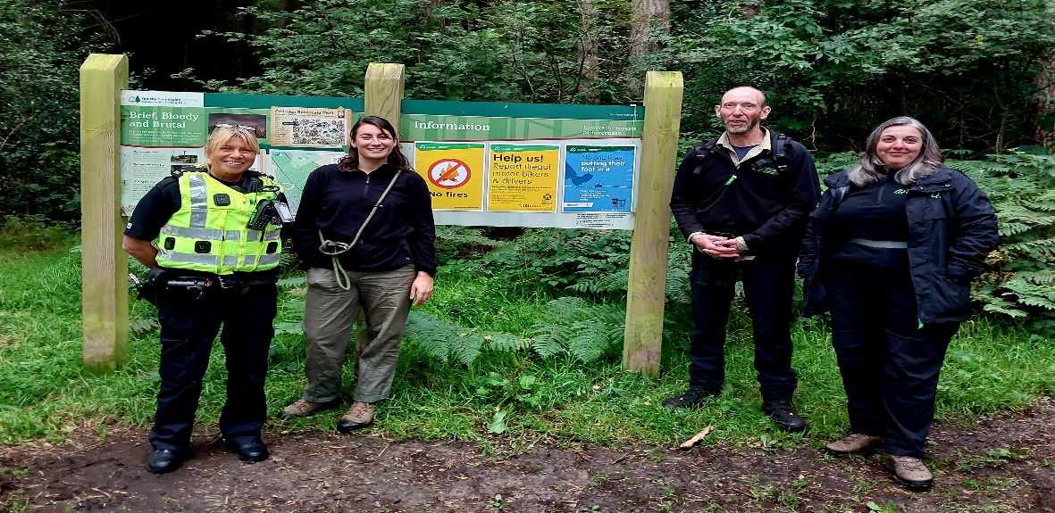
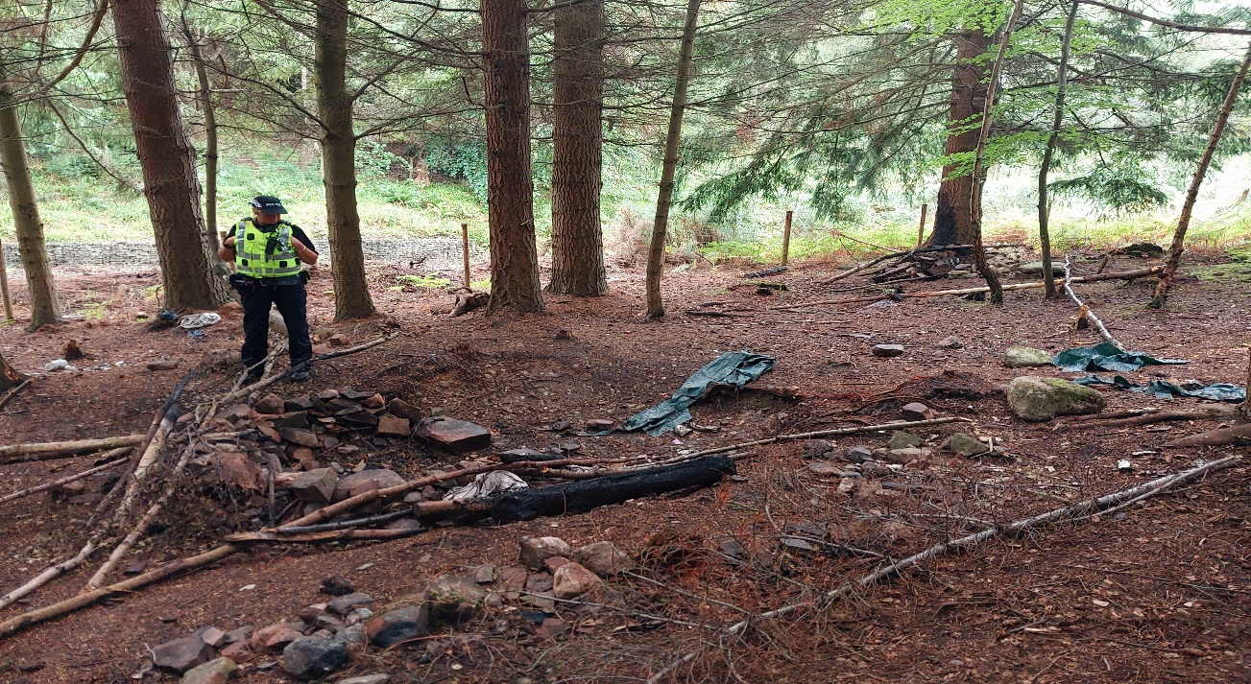
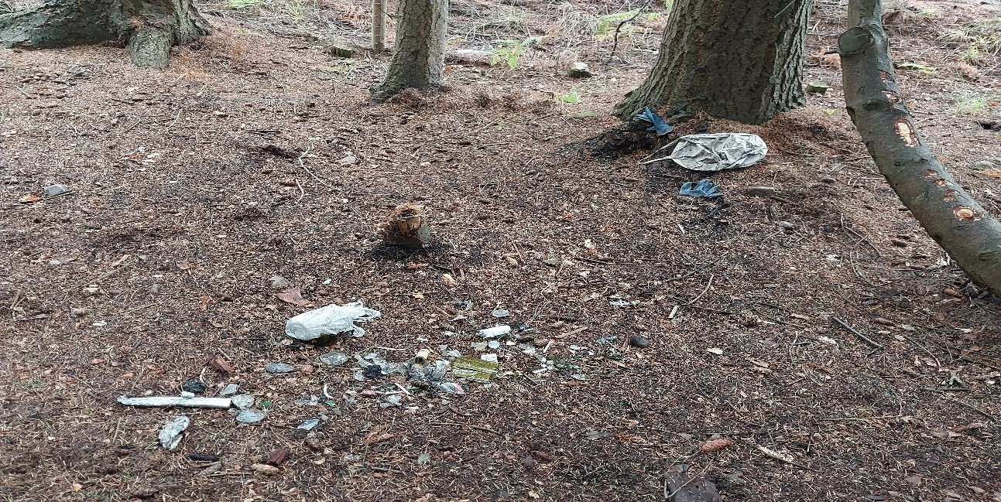


Drugs
Following reports of drug dealing activity in and around Inverness community beat officers we have provided targeted patrols on foot, bike and mobile patrol.
We continue to work closely with our Intelligence unit who have been granted and executed numerous warrants across the city. These have resulted in drugs and cash being seized as productions, and those responsible reported to the Procurator Fiscal Inverness. We continue to work with the community and respond to concerns regarding drug dealing activity.

The following areas continue to highlight higher levels of drug activity; Merkinch, Hilton and Raigmore Estate. We continue to target patrols to areas highlighted by the community and rely on information provided as the ‘dealers’ will often move from one area to another following continued Police presence, for example lanes and other areas not immediately visible from the road.
Community beat officers continue to carry out searches of individuals to disrupt and deter drug dealing in your communities and continue to gather intelligence where we can. We do rely on people in the community passing information onto us.
Information regarding those involved in the misuse and supply of illegal drugs is crucial to enable Police enforcement activity. Information can be passed anonymously via Crime stoppers on 0800555111 or in strict confidence to your local community beat officer.

Community Engagement
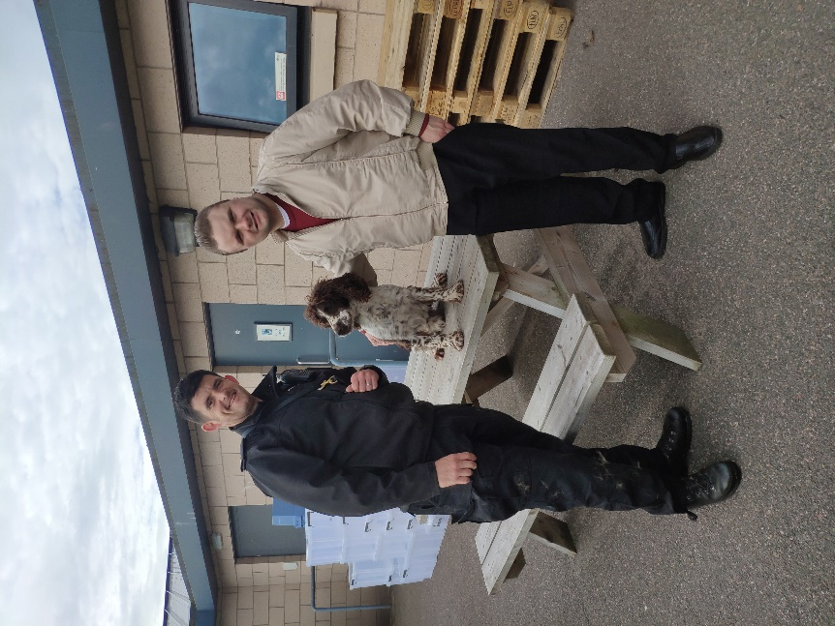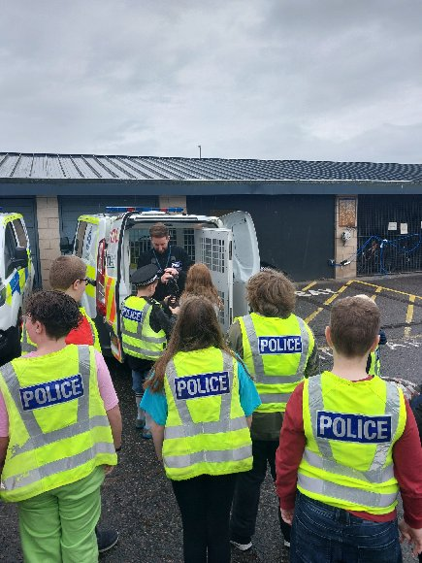
Officers have had visits to the station where groups have had a tour and learnt about how the station works and all the different departments within.
Hamish on the left got a chance to meet PC Joy and PD Corrie when he visited and the youth group were given the opportunity to dress in some uniform and see how we use the police vans and other equipment.

Other Duties
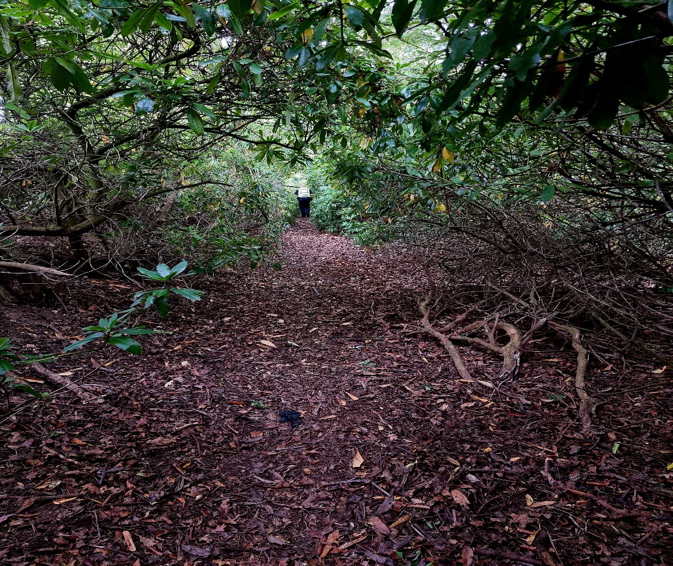
Community officers continue to assist the response shifts when needed and have been carrying out duties such as searching for missing persons and responding to emergency calls and ongoing serious incidents. We also continue to provide cover to others areas within our policing division to cover shortfalls in staffing and will continue to do so in the future.

Incidents of Note
There have been a number of incidents that may have seen an increased police presence in various locations through-out the city such as-
Kinymlies, Culloden, Westhill and South Kessock.
These areas have required an increase in police presence due to the serious nature of the crimes. Whilst the increase of officers may cause alarm to local residents, please be reassured that the increase of officers is to allow police to carry out thorough investigations into these incidents and bring have them concluded as soon as possible.
We will always try and contact local community councillors if an incident occurs that generates a lot of police activity in the area for an update and reassurance.

City Centre
“A proactive approach between Criminal Justice and Police Scotland has seen repeated antisocial behaviour affecting Falcon Square significantly reduce, with an individual responsible receiving a custodial sentence. Police continue to work with local charities to divert youths towards more constructive activities. Unfortunately, business representatives intimate that instances of shoplifting are on the increase. This is something we recognise and look to address in the coming weeks, both in terms of detection and enforcement, but also signposting offenders towards agencies who may be able to assist individuals who are economically struggling.”
“Antisocial ‘hot-spots’ identified to Police include Innes Street underpass, Farraline Park Bus Station and Falcon Square. As a consequence these areas are actively targeted with an increase in patrols (Police and BID task-team officers) CCTV monitoring and the disruption of analogous offending (purchase of alcohol, etc...) Wherever possible the City Centre Policing Team strive to provide a visible foot-patrol presence and work alongside BID Task Team Officers and Loss Prevention, utilising the ‘Shop safe’ radio-link, to provide a dynamic response for local businesses.
We have experienced a quiet month in terms of demonstrations/protests, and historically maintain a positive working relationship where we actively engage with protestors to ensure public safety, whilst recognising their legitimate right to action.”

Contact us

Police Scotland can be contacted via a variety of ways. In an emergency and/or when a crime is ongoing, please dial 999 otherwise please use the 101 phone number to report any other crimes or matters.
For non-urgent routines matters or to highlight issues or make contact with specific officers then the following email addresses can be used:

Inverness rural beats – Beauly / Cannich / Drumnadrochit / Fort Augustus / Foyers:
HighlandsandIslandsBeaulyFortAugustus@scotland.police.uk

For concerns and issues in the city of Inverness area and the rural beats of Ardersier, Daviot, Tomatin and Strathdearn:
HighlandsandIslandsCommunityBeatsInverness@scotland.police.uk

Please be aware that this e-mail address is not monitored 24/7 and is a contact email. Specific crimes should not be reported by these email addresses. Crimes should be reported via the telephone systems 999 or 101.
Any matters raised at community council meetings or specific community concerns should be emailed in and include the following details to enable your enquiry to deal with efficiently:
- Contact name
- Contact phone number
- Details of the issue – times/places/people/history of the issue

